Project Report

On

**Modern Library Management System**

-A Comprehensive Digital Solution

|  |  |
| --- | --- |
| Submitted By: |  |

# Boya Lalitha-----------------------21364027006

# Divte Tulasi ----------------------21364027011

# Golla Roopadevi -----------------21364027018

# Kamale Mahadevi ---------------21364027031

# Kanike Chandana ---------------21364027032

# 

# CERTIFICATE

Certified that this is a bonafide record of the project work titled

#### MODERN LIBRARY MANAGEMENT SYSTEM

**Done By:**

**Boya Lalitha**

**Divte Tulasi**

**Golla Roopadevi**

**Kamale Mahadevi**

**Kanike Chandana**

of VI semester BSc in the year 2024 in

partial fulfillment of the requirements for the award of Degree of Bachelor of Science

**AQUIB AJANI IIDT FSD FACULTY**

**Project Guide Head of the Division**

# ACKNOWLEDGEMENT

We take this occasion to thank God, almighty for blessing us with his grace and taking our endeavor to a successful culmination. We extend our sincere and heartfelt thanks to our esteemed guide, **AQUIB AJANI**, for providing us with the right guidance and advice at the crucial junctures and for showing me the right way. We also take this opportunity to express a deep sense of gratitude to **IIDT FSD FACULTY**. We would like to thank our friends and family for the support and encouragement they have given us during the course of our work.

**TABLE OF CONTENTS**

ABSTRACT 5

1. INTRODUCTION 6
   1. PROJECT AIMS AND OBJECTIVES 6
   2. BACKGROUND OF PROJECT 7
   3. OPERATION ENVIRONMENT 8
2. SYSTEM ANALYSIS 9
   1. SOFTWARE REQUIREMENT SPECIFICATION 10
   2. EXISTING VS PROPOSED 15
   3. SOFTWARE TOOL USED 17
3. SYSTEM DESIGN 20
   1. TABLE DESIGN 20
   2. DATA FLOW DIAGRAM’S 24
4. SYSTEM IMPLEMENTATION 29
   1. MODULE DESCRIPTION 29
   2. SCREEN SHOTS 30
5. SYSTEM TESTING 39
   1. UNIT TESTING 39
   2. INTEGRATION TESTING 41
6. CONCLUSION & FUTURE SCOPE 42
7. REFERENCES 43

### Abstract

### Modern Library Management system is a system that is used to maintain the records of the library. It contains work like the number of the available books, the number of books issued, the number of books to return or renew. It helps to maintain a database that is used to enter new books and records of books borrowed by the members with the respective submission dates. It will reduce the manual work done by librarian to maintain the record of the library. It allows maintaining the resources in a more operative manner that will help to save the time. It is also convenient for the librarian to manage the process of books allocation. It is useful for students as well as librarian to keep the constant track of the availability of all books in a library.

### User can search for books and renewal books online. They can recommend for new books by just sending messages to the librarian from any where in the college. They can view the issue and return dates of any book and due they have to pay. This system generates reports that can be used in analysing the library performance. Thus the management can take appropriate steps to improve the facilities.

CHAPTER

1.INTRODUCTION

This chapter gives an overview about the aim, objectives, backgrounds and operation environment of the system.

#### PROJECT AIMS AND OBJECTIVES

The project aims and objectives that will be achieved after completion of this project are discussed in this subchapter. The aims and objectives are as follows:

* + - Online book reading.
    - Improved Access to Resources
    - Enhances search capabilities
    - Catalog Management
    - Circulation and Borrowing Efficiency
    - Digital Resource Management
    - Integration with Educational and Information systems
    - Video tutorial for students.
      * An Admin login page where admin can add books, videos or page sources
      * Open link for Learning Websites

#### BACKGROUND OF PROJECT

The Modern Library Management System has evolved significantly over time. It began with manual cataloging systems, where librarians kept records of books and borrowers on paper. With the advent of computers, these systems transitioned to digital databases. Today, modern library management systems are comprehensive software solutions that automate various tasks such as cataloging, circulation, acquisitions, and patron management. They often include features like online catalog access, self-checkout kiosks, and integration with digital resources. These systems streamline library operations, improve efficiency, and enhance the user experience for both librarians and patrons.

All these modules are able to help librarian to manage the library with more convenience and in a more efficient way as compared to library systems which are not computerized.

|  |  |
| --- | --- |
| PROCESSOR | INTEL CORE PROCESSOR OR BETTER PERFORMANCE |
| OPERATING SYSTEM | WINDOWS VISTA, WINDOWS7, UBUNTU |
| MEMORY | 1GB RAM OR MORE |
| HARD DISK SPACE | MINIMUM 3 GB FOR DATABASE USAGE FOR  FUTURE |
| DATABASE | MYSQL, MONGODB |
|  |  |

## CHAPTER 2

**SYSTEM ANALYSIS**

In this chapter, we will discuss and analyze about the developing process of Modern Library Management System including software requirement specification (SRS) and comparison between existing and proposed system. A Modern Library Management System (LMS) is an integrated system designed to manage the operations of a library in a comprehensive way. It combines the use of software, hardware, and network systems to facilitate and enhance the efficiency of library services. The analysis of such a system involves understanding its key components, functionalities, and benefits.

#### SOFTWARE REQUIREMENT SPECIFICATION

* + 1. **GENERAL DESCRIPTION**

##### PRODUCT DESCRIPTION:

A Modern Library Management System (LMS) is a software solution designed to efficiently manage library resources, including books, journals, multimedia materials, and digital assets. It typically includes features such as:

1. Cataloging
2. Circulation Management
3. Patron Management
4. Accessibility and Customization
5. Resource Management

##### PROBLEM STATEMENT:

The problem occurred before having computerized system includes:

* File lost

When computerized system is not implemented file is always lost because of human environment. Sometimes due to some human error there may be a loss of records.

* Cataloging and Organization:

Maintaining accurate and up-to-date records of books and materials was cumbersome. Traditional card catalogs required manual updating, making it difficult to keep track of the available resources and their locations.

* + Space Management:

As collections grew, so did the need for physical space to store materials. This was a particular issue for libraries in urban areas where expansion space was limited or expensive.

* + Security and Preservation:

Monitoring the physical condition of materials and preventing theft or damage was challenging. There were limited means for tagging and tracking the physical state of items over time

* + Data Analysis and Reporting:

Gathering data on library usage, patron demographics, and collection development needs was difficult and time-consuming. This made strategic planning and reporting to stakeholders a challenge.

#### SYSTEM OBJECTIVES

* Efficient management of library resources:

Organizing, cataloging, and maintaining various types of materials, such as books, journals, and multimedia.

* Streamlined operations:

Automating routine tasks like cataloging, circulation, and inventory management to save time to improve productivity.

Enhanced user experience:

Providing patrons with easy access to library materials through online catalogs, self- Checkout systems, and personalized recommendations.

Accessible information:

Ensuring that users can find and retrieve information quickly and easily, whether through physical or digital means.

Data-driven decision-making:

Analyzing usage data to understanding patron preferences, improve collection development, and

Optimize resource allocation.

Compliance and security:

Adhering to industry standards and regulations to protect patron privacy and ensure the security of

library data and resources.

##### NON -FUNCTIONAL REQUIREMENTS

* + - * + Product Requirements EFFICIENCY REQUIREMENT

1.Response time:

Define acceptable response times for various actions within the system, such as searching for books, checking out items, or generating reports.

2.Throughtput:

Specify the maximum number of transactions or operations the system should handle within a given time frame, ensuring smooth and timely processing of request/

3.Scalablity Ensure the system can handle increasing loads gracefully by scaling resources such as servers, databases, and network bandwidth as demand grows.

4.Resource utilization: Monitor and optimize the use of system resources such as CPU, memory, storage, and network bandwidth to avoid bottlenecks and maximize efficiency.

5.Caching: Implement caching mechanisms to store frequently accessed data or computations, reducing the need for repeated processing and improving response times.

6.Concurrency: Define the maximum number of concurrent users or transactions the system should support without degradation in performance or reliability.

7.Batch processing: Utilize batch processing techniques for tasks that can be performed offline or in the background, minimizing the impact on real-time operations and improving overall system efficiency

8.Load balancing Distribute incoming request evenly across multiple servers or resources to prevent overloading of any single component and ensure optimal performance.

9.Compression and optimization: Employ compression algorithms and optimizations techniques to reduce data transfer times, minimize storage requirements, and improve overall system efficiency.

10.Monitoring and tuning: Continuosly monitor system performance metrics and adjust configuration settings or algorithms as needed to maintain optimal efficiency under varying loads and conditions.

##### RELIABILITY REQUIREMENT

1.System availability: Specify the desired uptime percentages, ensuring that the system is accessible to users for a significant portion of time without unplanned outages.

2.Fault tolerance: Design the system to withstand failures in hardware, software, or network components without compromising service availability or data integrity.

3.Data backup and recovery: Implement regular backups of library data and develop robust procedures for restoring data in case of accidental deletion, corruption, or system failure.

4. Redundancy: Introduce redundancy in critical system components such as servers, databases, and network connections to minimize the impact of failures and ensure conditions operations.

5. Monitoring and alerting: Set up monitoring tools to proactively detect potential issues such as performance degradation, resource exhaustion, or security breaches, and triggers alerts for timely intervention.

6.Disaster recovery: Develop a comprehensive disaster recovery plan outlining procedures for recovering the system and data in the event of catastrophic events such as natural disasters or cyberattacks.

7.Data consistency: Implement mechanisms to maintain data consistency across distributed components of the system, preventing discrepancies or conflicts that could arise due to concurrent access or system failures.

8.Failover and load balancing: Configure failover mechanism and load balancers to automatically redirect traffic to alternative servers or resources in case of failures, ensuring seamless continuity of service.

9.Security measures: Implement robust security measures such as encryptions, access controls, and intrusion detection system to protect against unauthorized access, data breaches, and others security threats.

10.Regular maintenance and updates: Establish a schedule for performing routine maintenance tasks such as software updates, security patches, and hardware inspections to keep the system running smoothly and mitigate potential risks.

##### USABILITY REQUIREMENT

The system is designed for a user friendly environment so that student and staff of library can perform the various tasks easily and in an effective way.

##### ORGANIZATIONAL REQUIREMENT IMPLEMENTATION REQUIREMNTS

1.Hardware and Software: Specifications for servers, computers, networking equipment, and software needed to run the system efficiently.

2.User Interface: Requirements for a user-friendly interface accessible to both library staff and patrons, including design elements, navigation, and accessibility features.

3.Database Management: Specifications for database structure, data storage, and management systems to organize and retrieve library resources effectively.

4.Cataloging and Metadata: Requirements for cataloging standards, metadata formats, and indexing methods to accurately describe and classify library materials.

5.Search and Discovery: Specifications for search functionalities, including keywords search options, filters, and relevance ranking algorithms.

6.User Management: Requirements for user accounts, authentication mechanisms, permissions, and privacy settings to manage library staff and patron access.

7.Checkout and circulation: Specification for circulation policies, loan periods, holds, renewals, and notification and returning of manage the borrowing and returning off library materials.

8.Acquisition and Collection Management: Requirements for ordering, receiving, cataloging, and processing new library materials collections, budgets, and vendor relationships.

9.Reporting and Analytics: Specifications for generating reports, collecting usage statistics, and analyzing data to access library services, collection usage, and user behavior.

10.Integration: Requirements for integrating with other library systems, such as integrated library systems (ILS), digital repositories, authentication systems, and third-party services.

11.Security and Privacy: Specifications for data security measures, encryption, access controls, backup procedures, and compliance with privacy regulations to perfect sensitive information.

12.Training and Support: Requirements for staff training, user documentation, technical support, and ongoing maintenance to ensure the system’s effective use and sustainability.

##### DELIVERY REQUIREMENTS

A modern library management system should offer features like cataloging, patron management, circulation management, circulation management, and reporting. It should also be user-friendly, accessible across devices, and capable of integrating with other systems. Additionally, it should prioritize security and data privacy, with features like role-based access control and encryption.

* + - 1. FUNCTIONAL REQUIREMENTS

1. NORMAL USER
   1. USER LOGIN

Description of feature

This feature used by the user to login into system. They are required to enter user id and password before they are allowed to enter the system .The user id and password will be verified and if invalid id is there user is allowed to not enter the system.

Functional requirements

-user id is provided when they register

-The system must only allow user with valid id and password to enter the system

-The system performs authorization process which decides what user level can acess to.

-The user must be able to logout after they finished using system.

##### REGISTER NEW USER

Description of feature

This feature can be performed by all users to register new user to create account.

Functional requirements

-System must be able to verify information

-System must be able to delete information if information is wrong

##### REGISTER NEW BOOK

Description of feature

This feature allows to add new books to the library Functional requirements

-System must be able to verify information

-System must be able to enter number of copies into table.

- System must be able to not allow two books having same book id.

1.5 SEARCH BOOK

One popular book on modern library management systems is “Managing the modern library: principles and practices “by Audrey Marshall and kathleen L. Vine. It covers various aspects of library management in today’s digital age.

##### DESCRIPTION OF FEATURE

This feature is found in book maintenance part. we can search book based on book id, book name, publication or by author name.

Functional requirements

* System must be able to search the database based on select search type
* System must be able to filter book based on keyword entered
* System must be able to show the filtered book in table view

Functional requirements

-System should be able to add detailed information about events.

-System should be able to display information on notice board available in the homepage of site

#### SOFTWARE AND HARDWARE REQUIREMENTS

This section describes the software and hardware requirements of the system

##### SOFTWARE REQUIREMENTS

* + - * + Operating system- Windows 7 is used as the operating system as it is stable and supports more features and is more user friendly
        + Database MYSQL-MYSQL is used as database as it easy to maintain and retrieve records by simple queries which are in English language which are easy to understand and easy to write.
        + Development tools and Programming language- HTML is used to write the whole code and develop webpages with css, java script for styling work and php for sever side scripting.

##### HARDWARE REQUIREMENTS

* nd

Intel core i5 2 generation is used as a processor because it is fast than other

processors an provide reliable and stable and we can run our pc for longtime. By using this processor we can keep on developing our project without any worries.

* + Ram 1 gb is used as it will provide fast reading and writing capabilities and will in turn support in processing.

**Existing System:**

1. Early days Libraries are managed manually. It required lot of time to record or to retrieve the details. The employees who have to record the details must perform their job very carefully. Even a small mistake would create a lot of problems. Security of information is very less. Report generations of all the information is very tough task.
2. Maintenance of Library catalogue and arrangement of the books to the catalogue is very complex task. In addition to its maintenance of member details, issue dates and return dates etc. manually is a complex task.
3. All the operations must be performed in perfect manner for the maintenance of the library without any degradation which may finally result in the failure of the entire system.
4. A modern library management system typically includes features like cataloging and indexing books, managing memberships, tracking borrowing and returning of books, generating reports, and possibly integrating with digital resources and online catalogs.
5. It often incorporates technologies like RFID for book tracking, barcode scanning or checkouts, and may have online capabilities for reservation and renewals.

**Proposed System:**

To solve the inconveniences as mentioned in the existing system, an **Online Library** is proposed. The proposed system contains the following features:

* + The students will register them through Online
  + Individually each member will have his account through which he can access the information he needs.
  + Book details like authors, number of copies totally maintained by library, present available number of books, reference books, non-reference books etc. all this information can be made handy.
  + Regarding the members designation, number of books was issued.
  + Issue dates and returns of each member is maintained separately and fine charged if there is any delay in returning the book.
  + Administrator can add, update the books.
  + Time consuming is low, gives accurate results, reliability can be improved with the help of security.

#### SOFTWARE TOOLS USED

The whole Project is divided in two parts the front end and the back end.

* + 1. Front end

The front end is designed using of html, Php,css, Java script

HTML- **HTML**or**Hyper Text Markup Language**is the main markuplanguage for creating web pages and other information that can be displayed in a web browser.HTML is written in the form of HTML elements consisting of *tags* enclosed in angle brackets (like <html>), within the web page content. HTML tags most commonly come in pairs like <h1> and </h1>, although some tags represent *empty elements* and so are unpaired, for example <img>. The first tag in a pair is the *start tag*, and the second tag is the *end tag* (they are also called *opening tags* and *closing tags*). In between these tags web designers can add text, further tags, comments and other types of text-based content. The purpose of a web browser is to read HTML documents and compose them into visible or audible web pages. The browser does not display the HTML tags, but uses the tags to interpret the content of the page.HTML elements form the building blocks of all websites. HTML allows images and objects to be embedded and can be used to create interactive forms. It provides a means to create structured documents by denoting structural semantics for text such as headings, paragraphs, lists, links, quotes and other items. It can embed scripts written in languages such as JavaScript which affect the behavior of HTML web pages.

 CSS- **Cascading Style Sheets**(**CSS**) is a style sheet language used fordescribing the look and formatting of a document written in a markup language. While most often used to style web pages and interfaces written in HTML and XHTML, the language can be applied to any kind

of XML document, including plain XML, SVG and XUL. CSS is a cornerstone specification of the web and almost all web pages use CSS style sheets to describe their presentation.CSS is designed primarily to enable the separation of document content from document presentation, including elements such as the layout, colors, and fonts. This separation can improve content accessibility, provide more flexibility and control in the specification.

of presentation characteristics, enable multiple pages to share formatting, and reduce complexity and repetition in the structural content (such as by allowing for table less web design).CSS can also allow the same markup page to be presented in different styles for different rendering methods, such as on-screen, in print, by voice (when

read out by a speech-based browser or screen reader) and on Braille-based, tactile devices. It can also be used to allow the web page to display differently depending on the screen size or device on which it is being viewed. While the author of a document typically links that document to a CSS file, readers can use a different style sheet, perhaps one on their own computer, to override the one the author has specified. However if the author or the reader did not link the document to a specific style sheet the default style of the browser will be applied.CSS specifies a priority scheme to determine which style rules apply if more than one rule matches against a particular element. In this so-called *cascade*, priorities or *weights* are calculated and assigned to rules, so that the results are predictable.

JAVA SCRIPT- **JavaScript**(**JS**) is a dynamic computer programminglanguage. It is most commonly used as part of web browsers, whose implementations allow client- side scripts to interact with the user, control the browser, communicate asynchronously, and alter the document content that is displayed. It is also being used in server-side programming, game development and the creation of desktop and mobile applications. JavaScript is a prototype-based scripting language with dynamic typing and has first-class functions. Its syntax was influenced by C. JavaScript copies many names and naming conventions from Java, but the two languages are otherwise unrelated and have very different semantics. The key design principles within JavaScript are taken from

the Self and Scheme programming languages. It is a multi- paradigm language, supporting object-oriented, imperative,

and functional programming styles. The application of JavaScript to use outside of web pages—for example, in PDF documents, site-specific browsers, and desktop widgets—is also significant. Newer and faster JavaScript VMs and platforms built upon them (notably Node.js) have also increased the popularity of JavaScript for server-side web applications. On the client side, JavaScript was traditionally implemented as an interpreted language but just-in-time compilation is now performed by recent (post-2012) browsers.

PHP- **PHP** is a server-side scripting language designed for web development but also used as a general-purpose programming language. PHP is now installed on more than 244 million websites and 2.1 million web servers. Originally created by

Rasmus Lerdorf in 1995, the reference implementation of PHP is now produced by The PHP Group. While PHP originally stood for *Personal Home Page*, it now stands for *PHP: Hyper text Preprocessor*, a recursive backronym, PHP code is interpreted by a webserver with a PHP processor module, which generates the resulting web page: PHP commands can be embedded directly into an HTML source document rather than calling an external file to process data. It has also evolved to include a command-line interface capability and can be used

in standalone graphical applications. PHP is free software released under the PHP License. PHP can be deployed on most web servers and also as a standalone shell on almost every operating system and platform, free of charge.

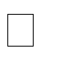MYSQL- **MySQL**("My S-Q-L", officially, but also called "My Sequel") is (as of July 2013) the world's second most widely used open-source relational database management system (RDBMS). It is named after co-founder Michael Widenius daughter, My. The SQL phrase stands for Structured Query Language. The MySQL development project has made its source code available under the terms of the GNU General Public License, as well as under a variety

of proprietary agreements. MySQL was owned and sponsored by a single for-profit firm, the Swedish company MySQL AB, now owned by Oracle Corporation

.MySQL is a popular choice of database for use in web applications, and is a central component of the widely used LAMP open source web application software stack (and other 'AMP' stacks). LAMP is an acronym for "Linux, Apache, MySQL, Perl/PHP/Python." Free-software-open source projects that require a full-featured database management system often use MySQL. For commercial use, several paid editions are available, and offer additional functionality. Applications which use MySQL databases

include: TYPO3, MODx, Joomla, WordPress, phpBB, MyBB, Drupal and other software. MySQL is also used in many high-profile, large-scale websites, including Wikipedia, Google (though not for searches), Facebook, Twitter, Flickr, and

YouTube

## CHAPTER 3 SYSTEM DESIGN

#### TABLE DESIGN

VARIOUS TABELS TO MAINTAIN INFORMATION

* **Library** **Table** **from** **Database**

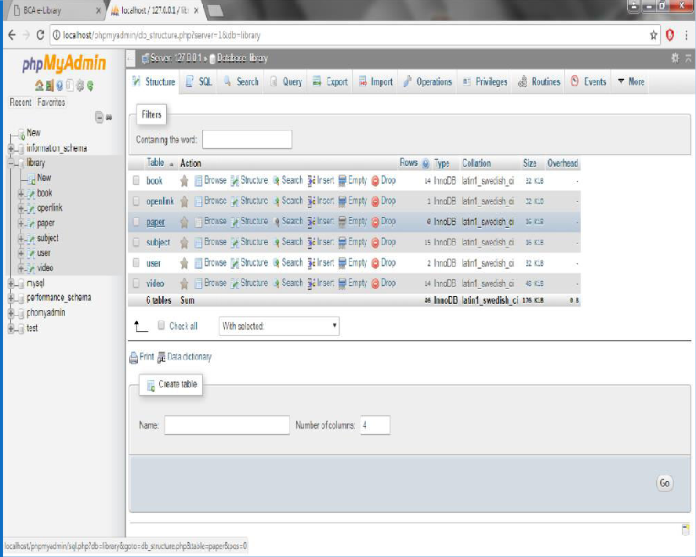

* **Admin** **Table** **from** **Database**

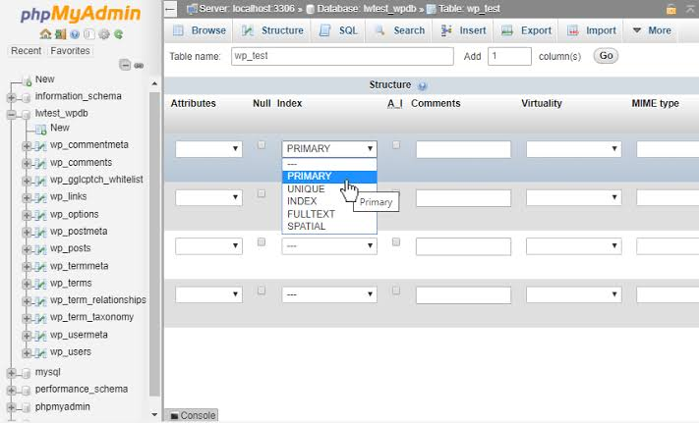

* **Subjects Table from Database**

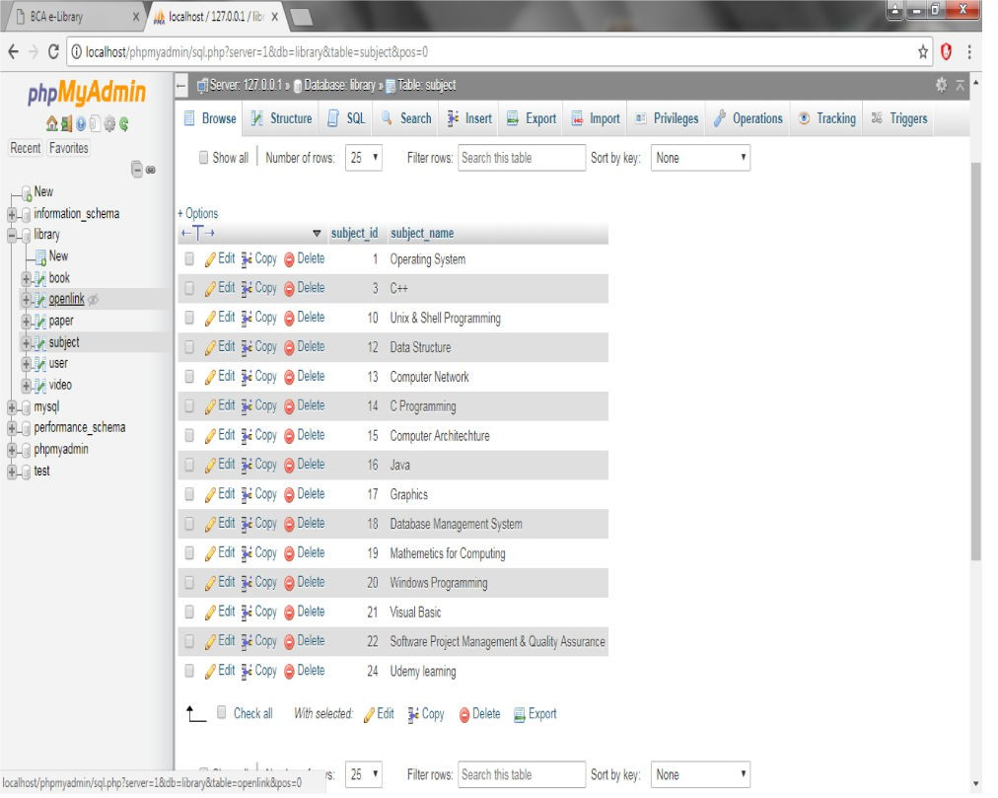

* **Books** **Table** **from** **Database** **Books** **Table** **from** **Database**

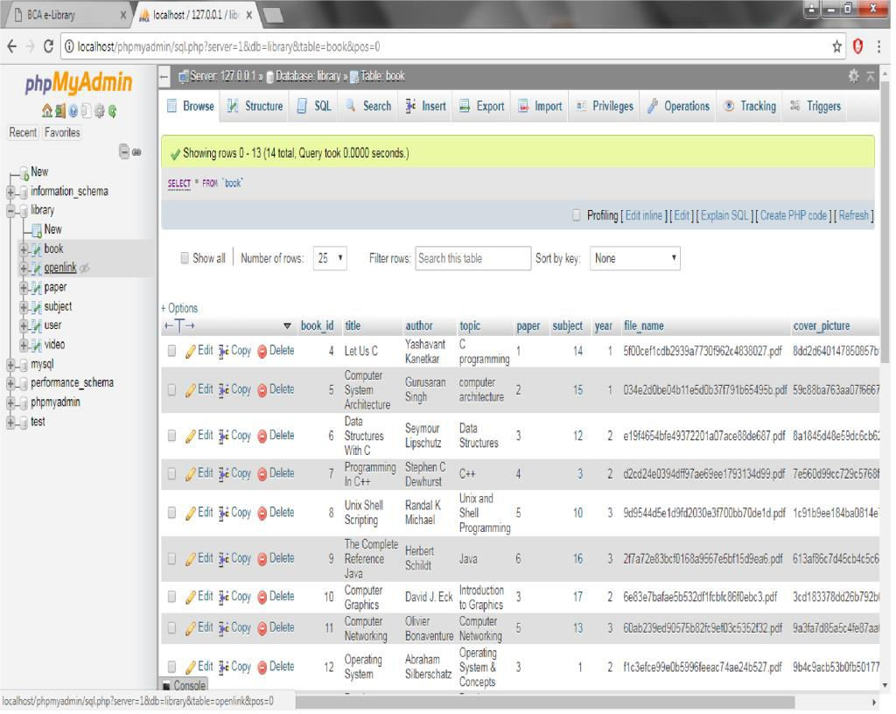

* + **Videos** **Table** **from** **Database**

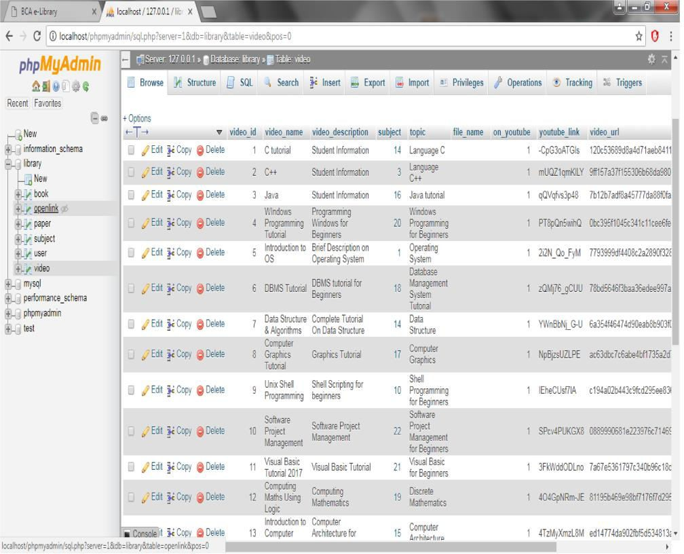

* + **Open** **link** **Table** **from** **Database**

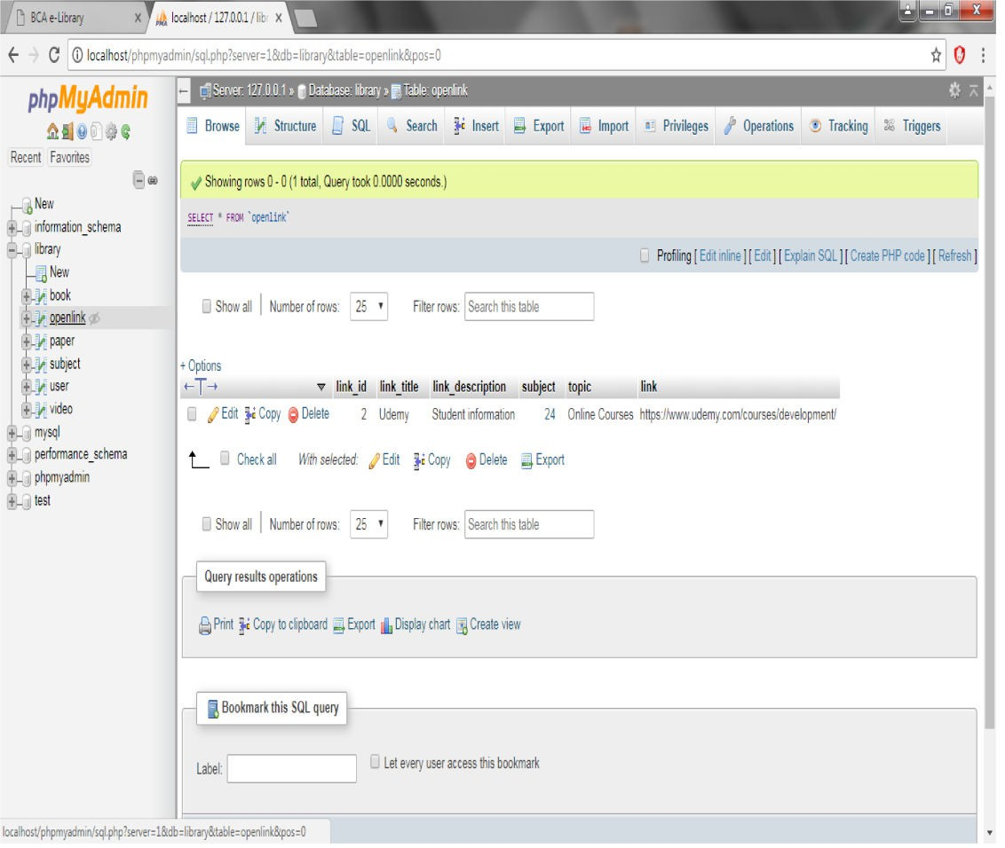

**3.2 DATA FLOW DIAGRAMS**

DATA FLOW DIAGRAM FOR ASMIN LOGIN

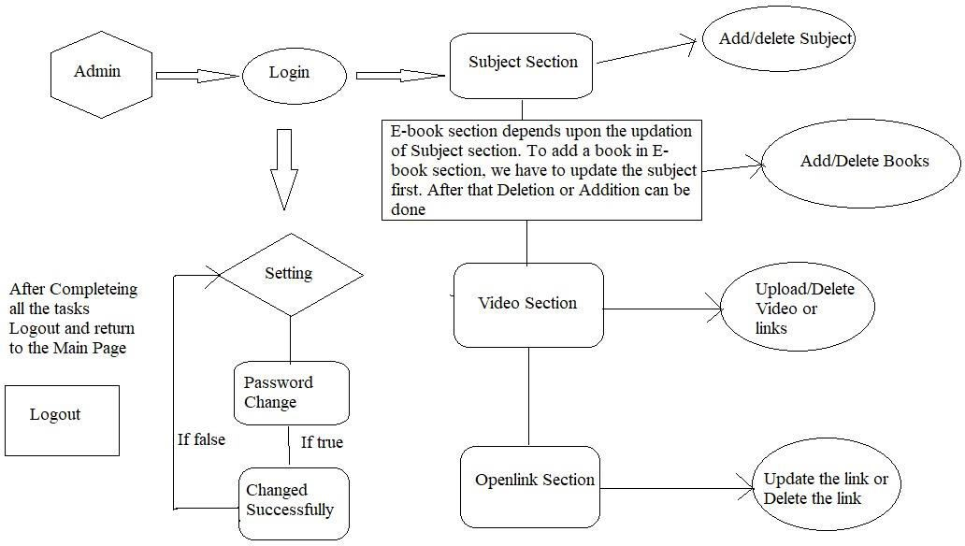

After entering to the home page of the website, Admin can choose the Admin Login option where they are asked to enter username & password

, and if he/she is a valid user then a teacher login page will be displayed.

USE CAESE DIAGRAM FOR USER

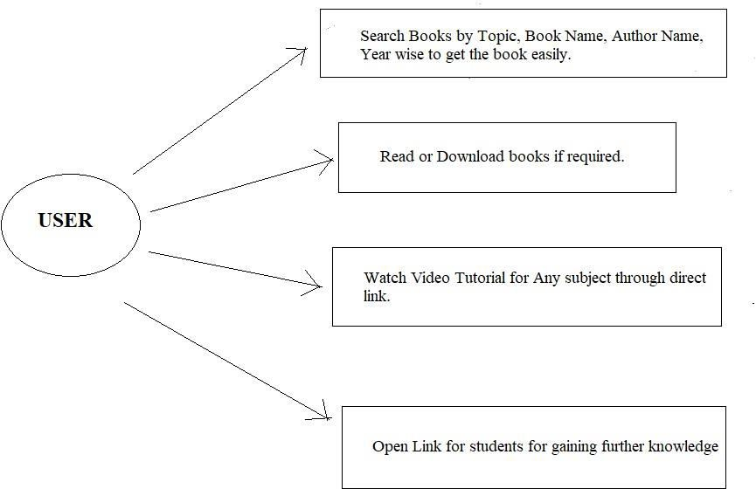

After entering to the home page of the website, student can choose the USER LOGIN option where they are asked to enter username & password, and if he/she is a valid user then a student login page will be displayed.

DATA FLOW DIAGRAM FOR USER

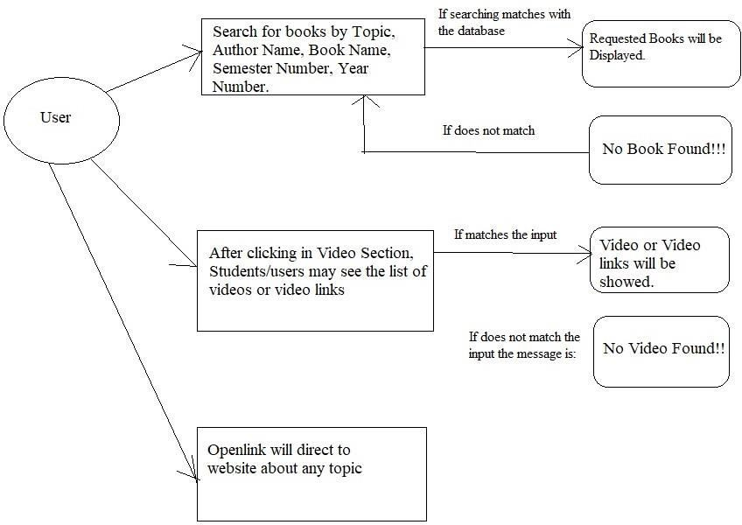

USER CASE DIAGRAM FOR ADMIN

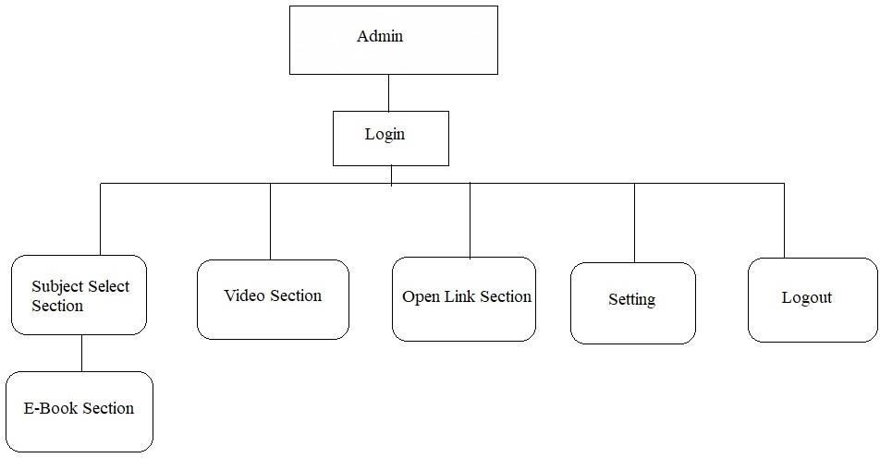

SEQUENCE DIAGRAM

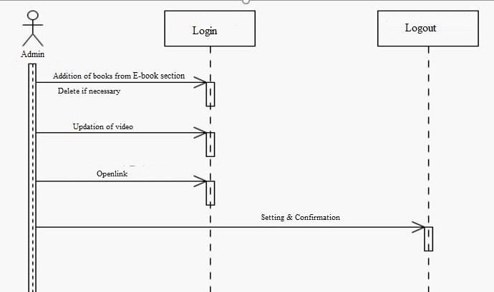

## CHAPTER 4 SYSTEM IMPLEMENTATION

**4.1 Screenshot for homepage**



* 1. **Screenshot of e-books from user.**

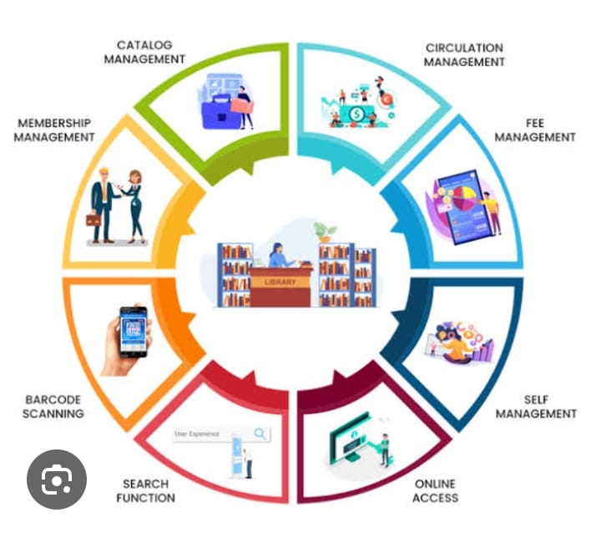

* 1. **Screenshot of videos from user**

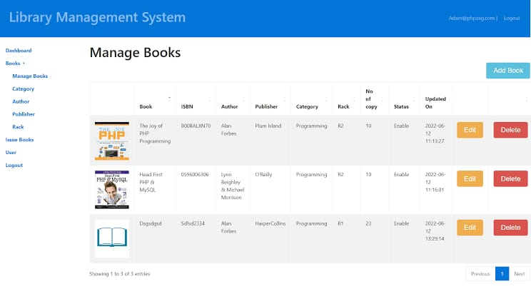

* 1. **Screenshot of open-link from user**
  2. 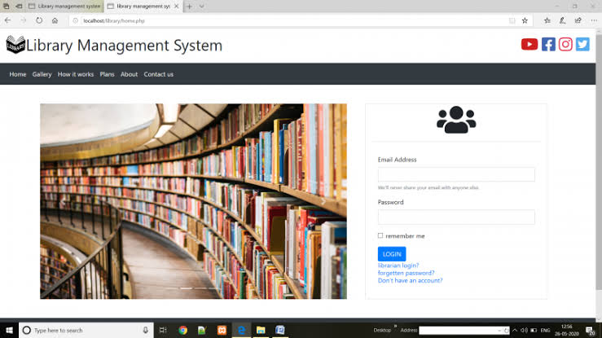
  3. **Screenshot of login for admin**

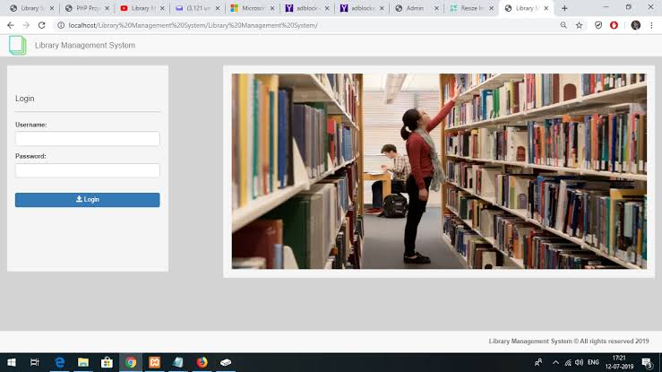

* 1. **Screenshot of online-book from admin**

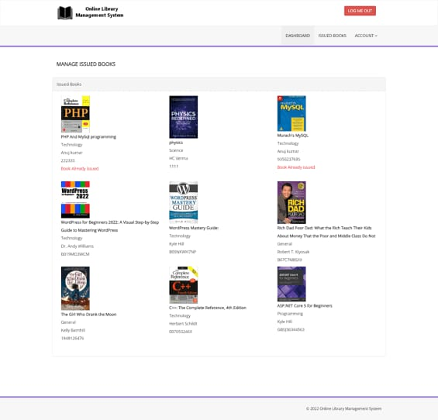

* 1. **Screenshot of videos from admin**

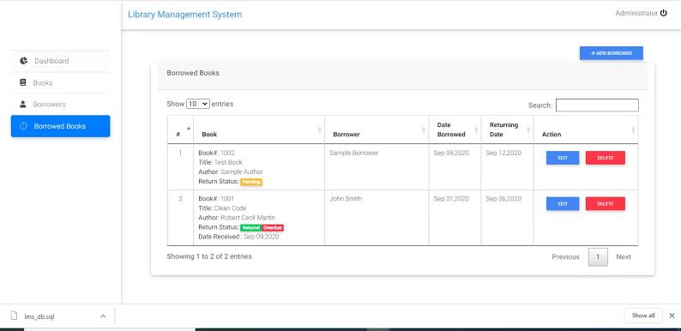

* 1. **Screenshot of open-link from admin**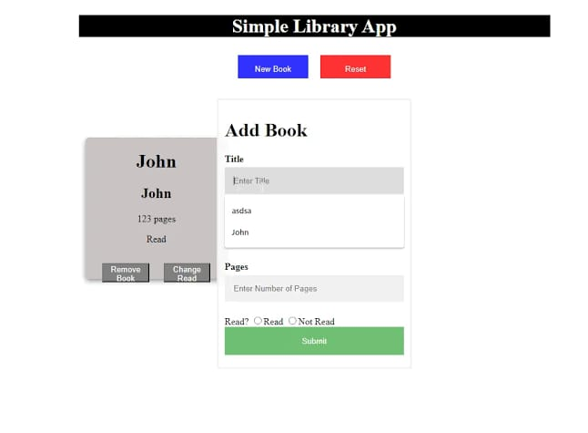
  2. **Screenshot of subjects from admin**

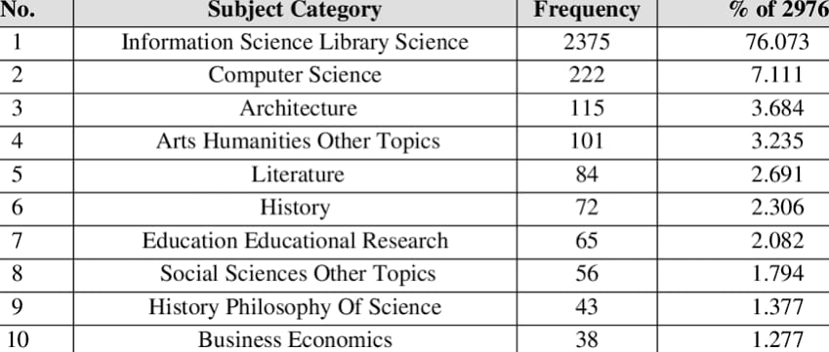

* 1. **Screenshot of settings from admin**

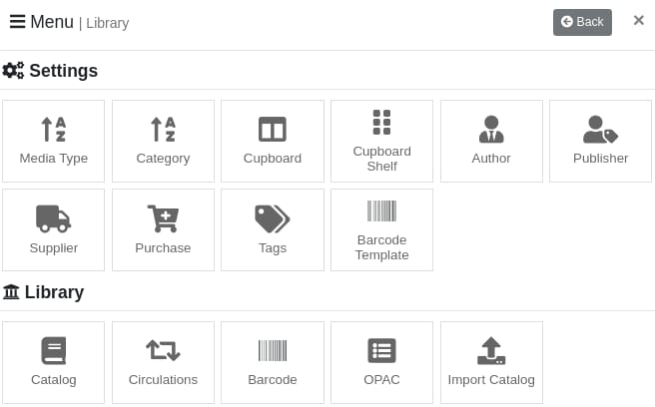

#### 5.1 MODULE DESCRIPTION

For Library Management System it is divided into the following Modules:

# CHAPTER 5 SYSTEM TESTING

The aim of the system testing process was to determine all defects in our project .The program was subjected to a set of test inputs and various observations were made and based on these observations it will be decided whether the program behaves as expected or not. Our Project went through two levels of testing

1. Unit testing 2.integration testing

## UNIT TESTING

Unit testing is undertaken when a module has been created and succesfully reviewed .In order to test a single module we need to provide a complete environment ie besides the module we would require

* + The procedures belonging to other modules that the module under test calls
  + Non local data structures that module accesses
  + A procedure to call the functions of the module under test with appropriate parameters

Unit testing was done on each and every module that is described under module description of chapter 4

* + 1. Test For the admin module
       - Testing admin login form-This form is used for log in of administrator of the system.In this we enter the username and password if both are correct administration page will open other wise if any of data is wrong it will get redirected back to the login page and again ask for username and password
       - Student account addition- In this section the admin can verify student details from student academinc info and then only add student details to main library database it contains add and delete buttons if user click add button data will be added to student database and if he clicks delete button the student data will be deleted
       - Book Addition- Admin can enter details of book and can add the details to the main book table also he can view the books requests .
    2. Test for Student login module
       - Test for Student login Form-This form is used for log in of Student .In this we enter thelibraryid, username and password if all these are correct student login page will open other wise if any of data is wrong it will get redirected back to the login page and again ask for libraryid, username and password.
       - Test for account creation- This form is used for new account creation when student does not fill the form completely it asks again to fill the whole form when he fill the form fully it gets redirected to page which show waiting for conformation message as his data will be only added by administrator after verification.
    3. Test for teacher login module-

Test for teacher login form- This form is used for logg in of teacher .In this we enter the username and password if all these are correct teacher login page will open other wise if any of data is wrong it will get redirected back to the login page and again ask for username and password.

## INTEGRATION TESTING

In this type of testing we test various integration of the project module by providing the input

.The primary objective is to test the module interfaces in order to ensure that no errors are occurring when one module invokes the other module.

# CHAPTER 6 CONCLUSION & FUTURE SCOPE

In conclusion, a modern library management system streamlines operations, enhances user experiences, and improves efficiency through automation and digitization. It provides features like online cataloging, easy search options, user management, and analytics.This website provides a computerized version of library management system which will benefit the students as well as the staff of the library.

It makes entire process online where student can search books, staff can generate reports and do book transactions. It also has a facility for student login where student can login and can see status of books issued as well request for book or give some suggestions. It has a facility of teacher’s login where teachers can add lectures notes and also give necessary suggestion to library and also add info about workshops or events happening in our college or nearby college in the online notice board.

Future scope lies in integrating emerging technologies like artificial intelligence for personalized recommendations, blockchain for secure transactions and copyright management, and IoT for real-time monitoring of library assets. Additionally, enhancing accessibility through mobile apps and cloud-based solution can further advance library services. Continuous updates and user feedback integration will be crucial for adapting to evolving needs and technologies in the future.

There is a future scope of this facility that many more features such as online lectures video tutorials can be added by teachers as well as online assignments submission facility, a feature of group chat where students can discuss various issues of engineering can be added to this project thus making it more interactive more user friendly and project which fulfills each users need in the best way possible.

# CHAPTER 7 REFERENCES

<http://www.w3schools.com/html/html_intro.asp>

[http://www.Udemy.com/css/css_background.asp](http://www.udemy.com/css/css_background.asp) <http://www.w3schools.com/js/js_datatypes.asp>

